Timely Reflections
INLAND MISSIONAL DISTRICT
UNITED WOMEN IN FAITH

PRESIDENT’S PONDERINGS

Leadership Development Days presented virtually by National United Women in Faith leaders for District leaders last month asked participants to “ponder” three questions: How is God working through United Women in Faith, What is God calling us to as United Women in Faith, and Where is God calling YOU in your leadership in United Women in Faith? One “takeaway” that I have kept “pondering” is emphasis on “I” words: inspire, impact, influence, and I would add invite.
This far North Idaho winter has been unlike any other I can recall in my 63 years here. Snow, yes, but ICE that made venturing onto the roads treacherous and actually kept some homebound for weeks. I have been grateful for technology allowing me to be inspired by UWF Faith Talks and Voices from the Field, educated by Just Energy for All webinars, hold District and Conference meetings safely at home. I can connect with UWF sisters to check on them and encourage them by phone (it’s good to hear voices!). I can influence and hopefully make a positive impact on my legislators via phone and/or email following virtual Idaho Legislative Events. And, I can contact women by phone with a personal invitation to a UWF meeting or event.
Inland District Executive Team set two goals for 2023: meet or beat our Pledge to Mission and add two or more members per Local Unit. Achievable with your help!
My challenge: Where is God calling YOU as a UWF member?

Blessings,
Judy

FEBRUARY 2023

Inside this Issue
Page 1 President
Page 1 The Purpose
Page 2 Membership
Page 2 Calendar
Page 2 E & I
Page 2 Websites
Page 2 Secretary
Page 3 Local Unit News
Page 3 UMCOR Advance
Page 4 Mission Today Form
Page 5 Annual Meeting ‘save the date’
Page 6 Spiritual Retreat information
Page 7 Retreat Registration form

Page 9 Calendar & internet addresses

THE PURPOSE
The organized unit of United Women in Faith
shall be a community of women whose
PURPOSE is to know God and to experience freedom as whole persons through Jesus Christ;
to develop a creative, supportive fellowship;
and to expand concepts of mission through participation in the global ministries of the
United Methodist Church.

MEMBERSHIP NURTURE & OUTREACH

The new year is upon us and soon we will see signs of spring. This brings to mind new growth. We just finished our Inland district executive meeting and we discussed our goals for 2023. One goal that we added is growth. I am challenging every unit to see if they can grow by two or more members in 2023. Look around your churches, neighborhoods and even schools to see if there might be women that would benefit from the programs and mission outreach of United Women in Faith. We might even give a certificate to the Unit that grows the most in 2023. So, as we look forward to the coming year let us go forth and grow!

Sue McGovney
Secretary of Membership Nurture and Outreach

CALENDAR 2023
Timely Reflections is the newsletter of the
Inland Missional District United Women in Faith.
It is published four times per year. Complimentary copies are sent to the following: Pacific Northwest Conference Leaders, Conference UWF officers, Inland District UWF officers, other District Presidents in the PNW Conference, Local Inland District Unit UWF officers, Inland District Superintendent,
Inland District Pastors and the PNWC office. This newsletter is available online at pnwumc.org/uwfaith.
If your address changes, or you no longer wish to receive this newsletter, please contact Sharon Stovall at timelyreflections@peoplepc.com.

April 21 Inland Dist. Board SVUMC
April 28-30 Spiritual Retreat Lazy F
July 21-23 Mission u Yakima
July 29 Inland Dist. Board Sandpoint UMC
September 16 District Ann. Mtg. Sandpoint UMC
October 21-23 Conference Ann. Mtg. C2C
November 11 Inland. Dist. Board Zoom

OUR FACEBOOK PAGE helps us promote
upcoming District, Conference, Western Jurisdiction and National Events. It is also a great place to share and learn about Social Issues and Action Alerts. Help us utilize this tool in our mission work by sharing local events or social issues that you are aware of. facebook.com/uwomenfaith
Facebook.com/pnwuwfaith

Find United Women in Faith on:
WEBSITE: uwfaith.org
pnwumc.org/uwfaith
INSTAGRAM: Instagram.com/uwfaith
PINTEREST: Pinterest.com/uwfaith/created
TWITTER: Twitter.com/uwomenfaith
YOU TUBE: Youtube.com/user/uwfaith
FLICKR: Flickr.com/photos.UMWomen

SECRETARY

I would like to send a huge thank you to each unit for your timely help in updating the 2023 Inland Missional District Directory. This information is vital to establishing up-to-date communications within our district and beyond. Please keep me informed of any changes within your unit by contacting me at nanahen6@comcast.net . Or call me 509-924-5192 (h) 509-951-8525 (c)

Susan Henderson,
Secretary

EDUCATION AND INTERPRETATION

This is Charlene Mullis your Education and Interpretation Coordinator I have new Mission Today requirements for 2023. Gold Units at least 12 of the criteria, 6 of which must be marked with *. Silver units at least 6, 3 of which must be marked with *.
Reading Program keep on reading and keep track of what you read. If you watch Faith Talks keep track of those, also.

LOVE IN ACTION
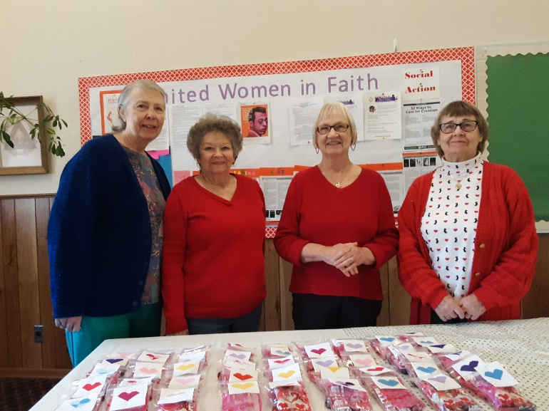
L to R: Roberta Decker, Joan Grater, Sharon Stovall, June Nelson
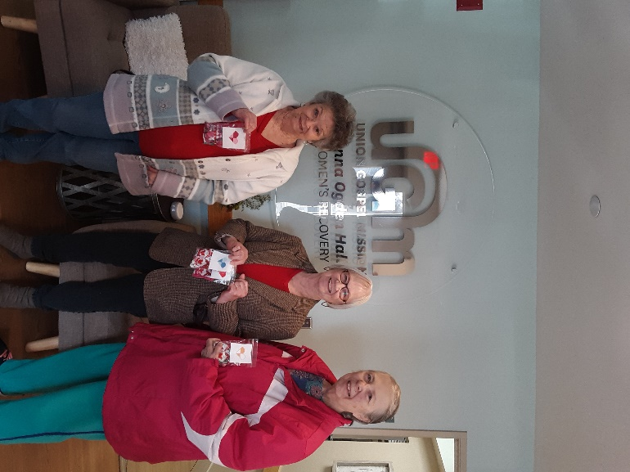
L to R: Joan Grater, Sharon Stovall, Roberta Decker
February 14, members of Fowler United Women in Faith delivered 47 bags of Valentine chocolates to the women and children staying at Anna Ogden Hall, a home for women recovering from addiction run by the Union Gospel Mission in Spokane.
Joan Grater made cross stitch hearts to place on each bag. The members filled the bags at our unit meeting February 2.
Three of us were given a tour of the facility and were introduced to members of the staff.

UMCOR DISASTER RELIEF FUND
ADVANCE # 982450 FOR DISASTER RESPONSE IN TURKEY AND SYRIA
Initial grants to UMCOR partner International Blue Crescent, which is headquartered in Turkey, and Forum for Development, Culture and Dialogue in Syria, are helping to provide tents, heaters, blankets, warm clothes, ready to eat meals and first aid kits to people affected by the devastating earthquakes. By giving through the Advance 100% of your donation reaches your chosen mission project or ministry.
To give online go to the Global Ministries/UMCOR website. To give by mail, make your check payable to GCFA, write the Advance number on the memo line of the check and mail to:
Global Ministries/UMCOR GPO
P. O. Box 9068
New York, NY 10087-9068

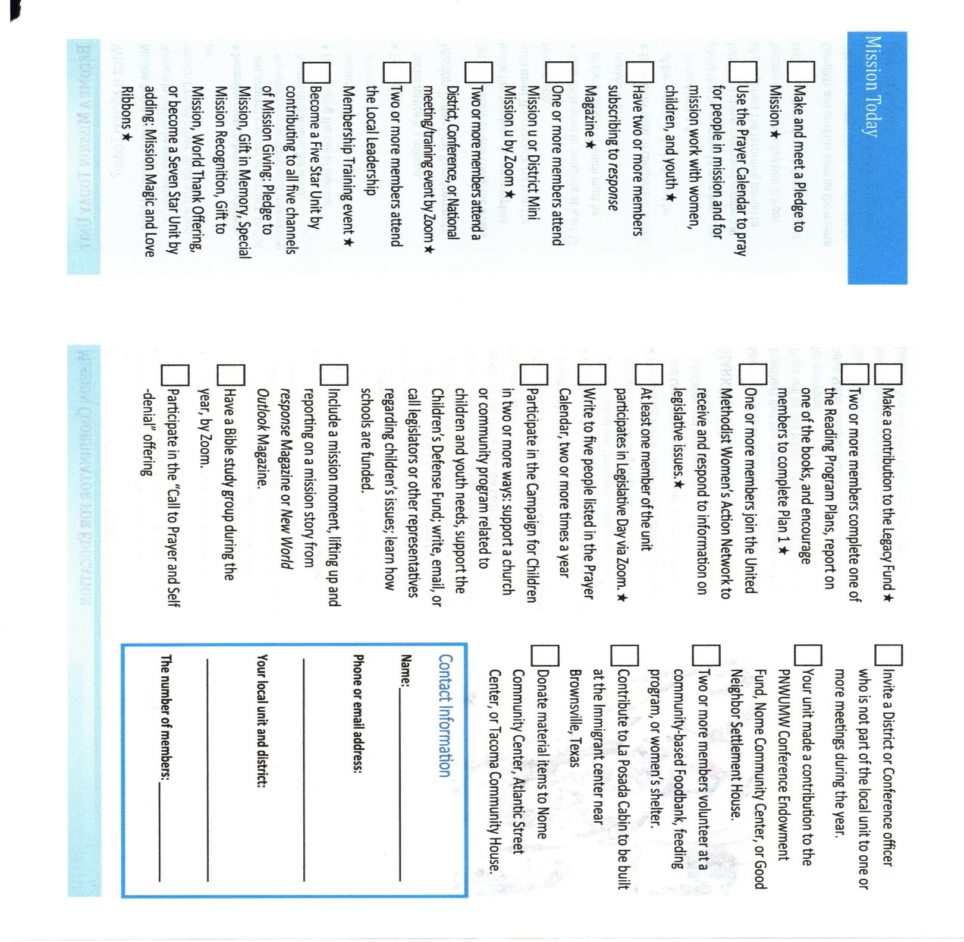

Send completed form to Charlene Mullis,
6931 Chippewa Drive
Bonners Ferry, Idaho 83805-7519

READING PROGRAM
The Reading Program Catalog can be found at uwfaith.org/resources/readingprogram/

SAVE THE DATE
INLAND MISSIONAL DISTRICT UNITED WOMEN IN FAITH
ANNUAL MEETING
THEME: “INVITE, INSPIRE, INFLUENCE,
WHAT DOES THAT LOOK LIKE?”
SEPTEMBER 16, 2023
Hosted by
Sandpoint United Women in Faith and Bonners Ferry
United Women in Faith
Sandpoint United Methodist Church
Sandpoint, Idaho

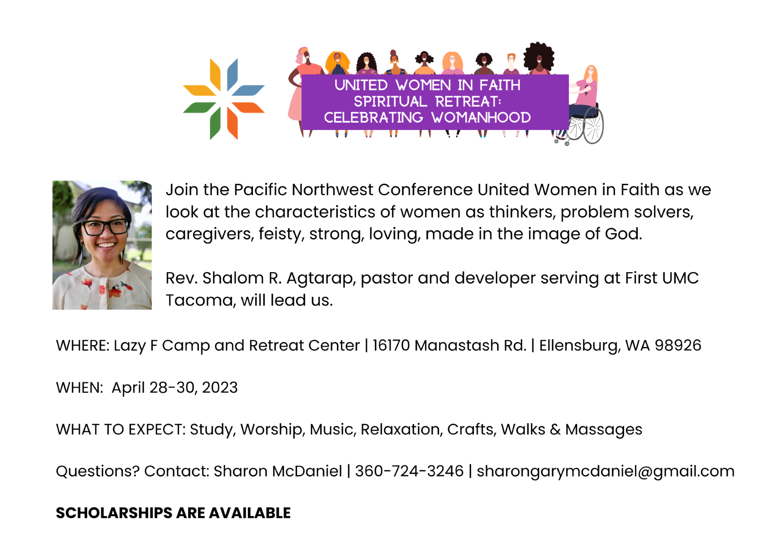

SPIRITUAL GROWTH RETREAT
April 28 - April 30, 2023 Check in 3-5 pm Friday Check out 11 am Sunday
Lazy F Camp and Retreat Center, 16170 Manastash Road, Ellensburg, WA 98926
Registration Deadline March 10, 2023
HEALTH HISTORY
Name_______________________________________Church__________________________
Mailing Address_______________________________________________________________
City___________________________________State_____________Zip__________________
Telephone_____________________________________email__________________________
Family Doctor or Healthcare Facility_______________________________________________
Address/City/State/Zip__________________________________________________________
Emergency Contact____________________________________Phone___________________
Secondary Contact____________________________________Phone___________________
> If you are taking medications at this time and bringing them to the retreat, please attach a list of medications.
> If you have special needs, dietary needs or restrictions which would affect your participation, please attach this information to the registration form.
> In signing this form, I hereby certify that this information is correct and complete as far as I know. I hereby give permission to the Retreat Leadership to provide routine health care, administer prescribed medications, and seek emergency medical treatment to include ordering x-rays or routine tests. In case of a medical need, I understand that every effort will be made to contact the above-named emergency contact person. In the event they cannot be reached, I hereby give permission to the physician selected by the Retreat Leadership to secure and administer treatment, including hospitalization. I agree to release any records necessary for insurance purposes. I authorize the use of photos for the future publicity.
Signature________________________________________Date_____________________ REGISTRATION
(Please check where appropriate)
---___$135.00 Skyline Cabin Upper Bunk (includes towel, bedding and 5 meals)
___$135.00 Skyline Cabin Lower Bunk (includes towel, bedding and 5 meals)
___$125.00 Ridgeview Upper Bunk (5 meals, provide own towel and bedding)
___$125.00 Ridgeview Lower Bunk (5 meals, provide own towel and bedding)
___$120.00 Trading Post Upper Bunk (5 meals, provide own towel and bedding)
___$120.00 Trading Post Lower Bunk (5 meals, provide own towel and bedding) *SKYLINE ASSIGNMENTS ARE ON A FIRST-COME, FIRST-SERVE BASIS.
Please List Roommates___________________________________________
Make checks payable to: Pacific Northwest Conference UMW
Please send completed registration form and check total of____________ To: Sharon Stovall at 2311 E. Marshall, Spokane, WA 99207-5438.
Email shrstovall@peoplepc.com for more information
____Check if you plan to have a Chair Massage at an additional $15.00. (To be paid on site)
Conference Scholarship form is on the PNWC UWF website, requests go to Linda Mills - wmil1218@aol.co or 12431 SE 198th Pl., Kent, WA 98031-0600

Please note, rooms at Skyline are full.

Inland Missional District
United Women in Faith
3928 N. Howard
Spokane WA 99205

