Timely Reflections
Inside this Issue
Page 1 President
Page 1 Directory Changes
Page 2 United Women in Faith
Page 2 The Purpose
Page 2 Calendar
Page 2 Facebook Page
Page 3 Book Review
Page 3 Welcome Karen Peacock
Page 4 Mission u registration form
Page 5 Mission u form
Page 6 Save the Date Annual Mtg.

Page 9 Calendar & internet addresses

INLAND MISSIONAL DISTRICT
UNITED WOMEN IN FAITH

PRESIDENT’S PONDERINGS

How many times have I said, “I don’t like change!”? But I suddenly realize, I not only LIKE change, I WELCOME it! Those of you who have heard my Faith Story know the impact an incident when I was a seven-year- old Brownie had on me. A field trip from Evanston to Chicago to tour the newspaper office included a lunch stop. We were prohibited from entering the restaurant. One of the Brownies was black. Without realizing it at the time, this was just one time God put me on a path of a life-long fight for change—for racial justice. Our sisters have recognized a need for change in our beloved organization. I am already trying to get used to our name change to United Women of Faith. Isn’t “united” exactly what I have been endeavoring to bring about since I was that Brownie hurting for my black friend? To bring about full inclusion for ALL through responding to needs we might not have been aware of before? To welcome ALL women of faith who wish to belong to our organization? We remain the only official women’s organization of the United Methodist Church. Invite ALL your friends to join us!
As we change together,
President, Judy Dirks
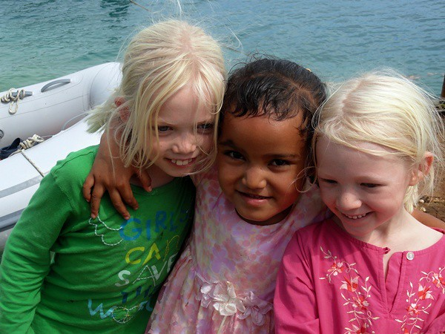

May 2022

INLAND DISTRICT DIRECTORY UPDATE 4-30-22

1) Page 5: GNW Shared Annual Conference is on Zoom
2) Page 12: Endowment Committee -Remove Sara Culp
3) Page 13: Crest to Coast Missional District
Presently the Convener is Sue
Sue Raymond sueraymond@bellsouth.net
3934 Berwick Lane SE, Olympia, WA 98501,
770-843-2790.
4) Page 33: Websites
uwfaith.org pnwumc.org/uwfaith
Facebook.com/uwomenfaith
Facebook.com/pnwuwfaith
Instagram.com/uwfaith
Pinterest.com/uwfaith/created
Twitter.com/uwomenfaith
Youtube.com/user/uwfaith
Flickr.com/photos/UMWomen
THE PURPOSE
The organized unit of United Methodist Women shall be a community of women whose PURPOSE is to know God and to experience freedom as whole persons through Jesus
Christ; to develop a creative, supportive fellowship; and to expand concepts of mission through participation in the global ministries of the United Methodist Church.
Timely Reflections is the newsletter of the
Inland Missional District United Methodist Women
It is published four times per year. Complimentary copies are sent to the following: Pacific Northwest Conference Leaders, Conference UMW officers, Inland District UMW officers, other District Presidents in the PNW Conference, Local Inland District Unit UMW officers, Inland District Superintendent,
Inland District Pastors and the PNWC office.
This newsletter is available online at pnwumc.org/umw.
If your address changes, or you no longer wish to receive this newsletter, please contact Sharon Stovall at timelyreflections@peoplepc.com.

WE ARE UNITED WOMEN IN FAITH
As United Methodist Women refreshes its look, it embarks on a bold journey of nurturing sisterhood with a new name to reflect a bright future.

In 150 years in mission, our organization has had more than 25 names, each reflecting the varying ties, ways women lived their lives and the states of union of our many predecessor denominations.

We’ve been “Ladies,” Woman’s” and Women’s” societies, associations, guilds and circles. We’ve even had multiple names at the same time to include women in different life stages or styles, such as Wesleyan Service Guild for working women and Woman’s Society of Christian Service geared to the day’s many homemakers in the 1940’s. The name United Methodist Women was adopted in 1972, signaling a change not only in the life of the church but in the lives of women and how they could organize for mission.

We are again facing a change in the life of the church and in how women live and choose to engage the world in faith. It is again time to take on a new name.
As United Women in Faith we are a powerful, fearless force driven by God’s love and united in sisterhood with a focus on women, children and youth. We act for
justice and transform communities. We invite United Methodist and other like-minded women to join us, because love in action can change the world.

We will maintain the legal name United Methodist Women while operating as United Women in Faith, similar to our time as United Methodist Women while officially the Women’s Division from 1972-2012. You’ll continue to see the name United Methodist Women used in some places, but as we move into the future, together we’ll be United Women in Faith.
We remain the official women’s organization of the United Methodist Church. We remain the organization training women for leadership, growing spiritually, transforming through education, and providing opportunities for service and advocacy. We remain women in mission who follow God’s call for our time.

Excerpt from response magazine article written by Yvette Moore

CALENDAR 2022

May 20-22 Assembly Orlando FL
June 9-12 GNW Annual Conference, Puyallup WA
July 21-21 Conf. UMW Exec. Selah UMC
July 22-24 Mission u Wesley UMC, Yakima WA
August 6 Inland District Exec. Spokane Valley UMC
August 8 Timely Reflections Articles Due
August 15 Timely Reflections Newsletter Out
September 17 Inland District Ann. Mtg. SVUMC
October 13-14 Conf. UMW Exec. Bothell UMC
October 14-15 Conf. Ann. Mtg. Bothell UMC
October 29 Inland District Exec. TBA
November 15 Fall Timely Reflections

OUR FACEBOOK PAGE helps us promote upcoming District, Conference, Western Jurisdiction and National Events. It is also a great place to share and learn about Social Issues and Action Alerts. Help us utilize this tool in our mission work by sharing local events or social issues that you are aware of.
Facebook.com/uwomenfaith
Facebook.com/pnwuwfaith
BOOK REVIEW
HOW TO BE ANTIRACIST by IBRAM X. KENDI
He went to a Christian Religious school 1st-8th grades. He went to Jamaica, in Queens when he was a freshman. He didn’t apply himself in High School, only enough to get by. White teachers would only let white children answer questions not Black children. The High School where he went had over-crowded classrooms. One Black kid beat up an Indian and stole his Walkman from him, on the bus he had to ride. His Dad thought he would get hurt playing basketball with other Black kids, so his dad put up a basketball hoop and cemented the back yard so he could play.
His parents moved to Manassas, Virginia when he was a sophomore, which was a predominantly white suburban neighborhood. He went to Stonewall Jackson High School. He gave a speech, Prince William County, Martin Luther King Jr. oratorical contest to win a scholarship to go to college. He won and went to Florida A & M University in 1999. It was a historically Black University.
His great grandfather was white. He wore orange contacts to change the color of his
eyes, made people think he was gay. One of his best friends was gay. When he married his wife ended up with breast cancer. After she recovered, she had a baby. He ended up with stage 4 colon cancer and took chemo. When he had surgery, the doctor found no cancer. He finished this book in 2018.
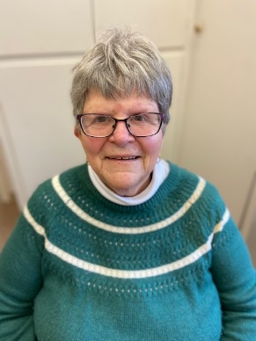

This book has a lot of facts and figures you have to read to see them all. Black people from America are treated worse than immigrants from Africa or other black people from India. Portugal imported slaves from Africa first. He told how immigration increased over the years of different races.
Antiracist is to recognize there is no such thing as racial behavior, Black behavior. There is no “Black gene”. Black people use skin lighteners as White people use tanning oil or sun lamps.
In 2004 black Ohio voters had to wait in line 52 minutes, which was 34 minutes longer than White voters. The Black people got tired of waiting to vote so they walked away. Bush won by 118,000 votes. The majority of Black Americans live in Black neighborhoods. The majority go to Black churches and schools. Whites go to white schools. Five hundred Black babies die each year in Birmingham from lack of proper food, shelter and medical facilities.
Charlene Mullis, Education and Interpretation

Welcome Karen Peacock
Inland Missional District
United Women in Faith
Spiritual Growth Coordinator
Karen Peacock has been a United Methodist Woman (United Women in Faith) since she was a young bride in 1970. She has served many of offices of both local and district. She has also served at the conference level. She enjoyed meeting women from all over the world at several Assemblies.
Karen is trained as a CLM and has a passion for serving people both figuratively and in a tangible way. She is currently a member of Audubon Park UMC in Spokane. She is putting her skills and passions to use by running a satellite food bank for 2nd Harvest. Karen has two sons, who live in Spokane with their families. She is owned by two cats, Katy and Kory. Besides her cats she loves music, reading and playing games on her phone. If you can relate to any of her loves, please contact her so you both can compare and brag. Karen can be reached at 509-808-4161 or by email at kjpeacock5604@gmail.com.

Registration Form – Mission u, July 22-24, 2022
Name for Badge ______________________________________________________________________
Address _____________________________________________________________________________
City ___________________________________ State __________________ Zip __________________
Phone: _____________________________________ Cell: _____________________________________
Email: ______________________________________________________________________________
Emergency Contact: __________________________________ Phone: __________________________
Insurance Carrier: _____________________________________________________________________
Can you open MS Word documents (Word.docx or PDF)? Yes No
Church ______________________________________________________________________________
District _________________________________________ Conference __________________________
Status: Have you ever attended Mission u? Yes ◯ No ◯
(Check all that apply): Pastor/Clergy ◯ Lay ◯ UWF ◯ UMM ◯ School Staff ◯
Are you a UWF Officer? Yes ◯ No ◯ Check all that apply: Local ◯ District ◯ Conference ◯
Gender: __________________________ Age Group: 8-11 ◯ 12-17 ◯ 18 & older ◯
Dietary: Meals are served in a buffet style. The caterer will work hard to accommodate most diets by providing a variety of options. Gluten free and diabetic choices will be available.
Food Allergies: _______________________________________________________________________
Meals included: Friday lunch and dinner and Saturday lunch and dinner.
Will you be needing lunch on Friday? Yes ◯ No ◯
ADA needs: We are happy to help you prepare for an enjoyable experience! Please share your challenges or concerns. If we don’t know before the event, we may not be equipped to assist:
___________________________________________________________________________________
If childcare was offered, would you need it? Yes ◯ or No ◯ Ages _______________
Children and Youth registrants: Completion of the Medical Release Form and Covenant for Responsible Adult Form mandatory for attendance. Youth must complete Youth Covenant Form. Find the forms here www.pnwumc.org/uwfaith/mission-u-forms.
Can we use your photo in promotional materials? Yes ◯ or No ◯
Can National Division use your contact information? Yes ◯ or No ◯
Study Books: Spiritual Growth Study books are available for purchase online at umwmissionresources.org.

Hotel Information
1. Ramada by Wyndham Yakima 2. Best Western Plus
(509) 249-1000 (509) 453-8898
1001 Staff Sgt. Pendleton Way 1614 N 1st St
Yakima, WA 98901 Yakima, WA 98901
Room Rates: $120.00 per night, plus taxes Room Rates: $129.00, per night plus taxes
Group Name: Group name:
PNW UMF Mission u 7/2022 United Women in Faith, Conf#1865
Registration Form – Mission u, July 22-24, 2022
Registration Cost
Early Bird Price — $125.00 — postmarked on or before June 25.
Regular Price — $150.00 — must be postmarked before July 8, 2022
Registration Price after July 8, 2022 — $165.00
***FUNDING PROVIDED BY***
Local Church/UWF | $ ________________  from: ____________________________________
District Church/UWF | $ ________________  from: ____________________________________
Conference Church/UWF | $ ________________  from: ____________________________________
Personal Check | $ ________________  from: ____________________________________
Total: | $ ________________ Participants responsible for the difference.
Total amount enclosed | $ ________________ Make checks payable to MISSION u
*Pre-payment, including scholarship funds, required. *NO payments accepted at Mission u.
Mail completed registration to:
Linda Mills, Registrar 12431 SE 198th Pl Kent, WA 98031
For questions call or text Linda at 206-399-2302
Or email: wmil1218@aol.com
Upon receipt of your registration, a confirmation letter will be sent out to you. If you indicate you have email and can receive and open attachments, the letter will be sent to you by email.

Scholarships
Scholarships are available for REGISTRATION FEES ONLY.
(See above for registration cost)
Scholarship Deadline July 1, 2022.
Please apply to your Local Church/UWF and District UWF first.
Application available at https://www.pnwumc.org/uwfaith/mission-u-forms
Scholarship contact: Linda Mills 206-399-2302 wmil1218@aol.com 12431 SE 198th Pl, Kent, WA 98031
Inland Missional District
United Methodist Women
3928 N. Howard
Spokane WA 99205

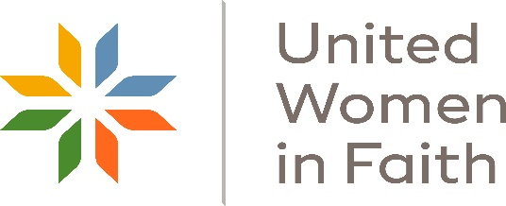
SAVE THE DATE!
Inland Missional District
United Women in Faith
2022 Annual Meeting

The Meeting will be on September 17, 2022
At Spokane Valley United Methodist Church
Spokane Valley WA

As plans are made, updates will be sent out
Patsy Charlton, Vice President

