TIMELY REFLECTIONS UNITED METHODIST WOMEN
INLAND MISSIONAL DISTRICT
Inside this Issue
Page 1 President
Page 1 Treasurer
Page 2 Sue McGovney Bio
Page 2 Program Resources
Page 2 Ed. & Interpretation
Page 3 Book Review/Calendar
Page 3 Directory Changes
Page 4 Websites/Mission u
Page 5 Mission u
Page 6 Save the Date/Annual Mtg.

Page 9 Calendar & internet addresses

THE PURPOSE
The organized unit of United Methodist Women shall be a community of women whose PURPOSE is to know God and to experience freedom as whole persons through Jesus
Christ; to develop a creative, supportive fellowship; and to expand concepts of mission through participation in the global ministries of the United Methodist Church.

PRESIDENT’S PONDERINGS
This seemingly unending, life-altering pandemic has called to mind for me the term “perseverance.” Scripture has much to say that informs us on this topic and the resulting HOPE. Romans 5:3-4 is familiar to many of our United Methodist Women sisters: “we also rejoice in our sufferings, because we know that suffering produces perseverance; perseverance, character; and character, hope.” Yet, there are women, children and youth living in situations that make believing these words, if known to them, hard even to hear. While we await a full return to our “normal” reality, I encourage you to
- learn how you and/or your unit can contribute to agencies in your community such as Food Bank, Crisis Line or Victim Services, Head Start, public schools including teachers, a school food program such as Backpack, foster care
- brighten at least one person’s day with a phone call or note, visit if possible
- participate in Faith Talks and share them with someone needing a lift in spirits
- make a quilt for Children-at-Risk
- make Christmas stockings for Atlantic Street Center
- register for and tune in to Still in Mission webinars with our missionaries
- join or form a book club and discuss books on our Reading Program
- and, of course, invite new women, especially those alone, to join your fellowship

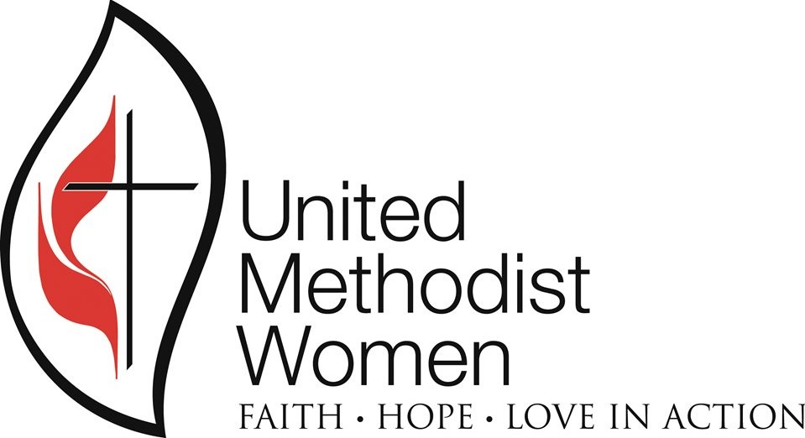
FEBRUARY 2022

James 5:11 says, “We consider blessed those who have persevered.” We are fortified through our Purpose and tag line
We are women of faith, hope-filled, with a goal of turning our love into action!
Journeying with you in perseverance,
Judy

TREASURER

Hello UMW Ladies. My name is Roberta Headley and I am the new district treasurer. My mailing address is 17008 E Bill Gulch Road, Mead WA 99021. Email address is beancounter87@yahoo.com . Please mail your 1st quarter monies to me by March 8, 2022 so that I can forward them to the Conference. Please feel free to contact me if you have any questions. Thank you.
For the month of January there has not been much activity to report.

I have worked as an accountant/bookkeeper for over 40 years. I am married and have two adult daughters. I attend church at Spokane Valley United Methodist Church.
BIO FOR SUE McGOVNEY
Timely Reflections is the newsletter of the
Inland Missional District United Methodist Women
It is published four times per year. Complimentary copies are sent to the following: Pacific Northwest Conference Leaders, Conference UMW officers, Inland District UMW officers, other District Presidents in the PNW Conference, Local Inland District Unit UMW officers, Inland District Superintendent,
Inland District Pastors and the PNWC office.
This newsletter is available online at pnwumc.org/umw.
If your address changes, or you no longer wish to receive this newsletter, please contact Sharon Stovall at timelyreflections@peoplepc.com.

PROGRAM RESOURCES AND MEMBERSHIP, NURTURE AND OUTREACH COORDINATOR
(The bio in the program book is incorrect.)

Sue McGovney is a long-time member of Spokane Valley United Methodist Church. At the local level for UMW she has served as President, Membership, Spiritual Growth and Communications. Sue is a gifted knitter and started a Prayer Shawl ministry at her church. At District UMW she has served as Communications, Programs Resources and on the Nominations committee. She has also served as Conference Program Resources Chair. Sue is recently widowed from Dick, her husband of 50 years. Sue has two children: a daughter who lives in Covington, WA with her husband and three terrific sons; and her son who lives in Portland, OR with his 7-year-old son. Sue spends most of her time with Freckles, her cocker spaniel. Sue enjoys knitting, sewing, the ocean and spoiling her grandsons. You can pick her out at UMW events as the one who is knitting.

EDUCATION AND INTERPRETATION
This is Charlene Mullis your Education and
Interpretation person.
Have your units working on the Mission Today list. To become a Gold Unit complete at least 12 of the criteria, 6 of which must be marked with *.
A Silver Unit has to complete 6 of the criteria, 3 of which must be marked with *. Units with under 15 members, use half of the above categories.
Mission u is July 22-24 hopefully in person at Yakima: Wesley UMC. Study Leaders are
Adult: Yvonne Agduyeng, Ron & Lois Hines and Nica Sy.
Youth: Golden Neal and Danielle Ramsey?
Children: Lyn Rush, and Sue & Terry Raymond.
Mission u Dean: Carol Mariano (revmariano@aol.com)
Registrar: Linda Mills

Charlene Mullis
charlenemullis@gmail.com
6731 Chippewa Drive
Bonners Ferry ID 83805

Justice Priorities of United Methodist Women for this quadrennium:
Maternal and child health
Economic justice
Climate justice
Criminalization of communities of color

PROGRAM RESOURCES ARE GOING DIGITAL

The future of United Methodist Women Resources is digital. The Program book will soon have a digital component that will be available for those that have already purchased the regular book for $5.00. By the end of the month there will be a digital version of the Daily Prayer Guide available as a Flipbook (e.g.) the reading program catalog and the response digital sampler. Did you know that the Daily Prayer Guide gives a daily update on Facebook? The programs for September to December are free to download.
To access these digital resources, go to United Methodist Women Digital Resources. You will have to sign up for a free membership but you will be able to get information and answers to your questions. I know I am a digital newbie but we can all travel into the future together.
Sue McGovney
smcgovney@gmail.com

BOOK REVIEW

Tattoos on the Heart: The Power of Endless Compassion, by Gregory Boyle, Founder of Homeboy Industries

Gregory Boyle grew up in the gang capital of the world Los Angeles, California. He is a Jesuit priest and the founder of Homeboy Industries, a gang intervention program located in the Boyle Heights neighborhood of Los Angeles. He writes in the slang of the Homeboys and Homegirls that he works with. He meets them on the streets and in the jails. When he meets them in jail, he tells them to call him when they get out. He’ll hook them up with a job, take off their tattoos or line them up with a counselor. They are offered chances to get an education. Many of them come to him at Homeboy Industries where they are provided a safe place. They are offered a job in one of the many businesses run by HBI, such as Homeboy Bakery, Homeboy/Homegirl Merchandising, screen printing and Homegirl Cafe. Often these gang members work with members of opposing gangs. This book is full of stories of shootings and deaths of gang members as well as triumphs of many of them. This book is full of short stories that will make you laugh and cry but it will also open your eyes to what their lives are like. They now have twenty-eight programs in the United States, from Spokane to Miami that have been modeled on their approach.

Sue McGovney
Inland District Program Resources

INLAND DISTRICT UMW 2022 CANLENDAR
March 18-20 Conf. Exec. Mtg. Lazy F Retreat Ctr.
March 23 Legacy Fund Day of Giving
March 30 Annual Membership Census Due
April 30 Inland Exec. Mtg. Bonners Ferry UMC
May 8 Timely Reflections Articles Due
May 15 Timely Reflections Newsletter Out
May 20-22 Assembly Orlando FL
June 9-12 GNW Annual Conference, Puyallup WA
July 21-21 Conf. UMW Exec. Selah UMC
July 22-24 Mission u Wesley UMC, Yakima WA
August 6 Inland District Exec. Spokane Valley UMC
August 8 Timely Reflections Articles Due
August 15 Timely Reflections Newsletter Out
September 17 Inland District Ann. Mtg. SVUMC
October 13-14 Conf. UMW Exec. Bothell UMC
October 14-15 Conf. Ann. Mtg. Bothell UMC
October 29 Inland Dist. Exec. TBA
November 15 Timely Reflections Newsletter Out
INLAND DISTRICT UMW DIRECTORY CHANGES -- 2022

ASOTIN: PAGE 14 Email Change
1) Karen Stewart: clbond56@gmail.com
2) Kristy Lee: kllee2453@gmail.com

BONNERS FERRY: page 17 Pastor’s Name Change
Pastor: Lee Books

CLARKSTON: page 19 Email Changes
1) SECRETARY:
Ada Bauchman: lbauchman525@centurylink.net

2)E&I: Barbara Dertinger: johnbarb414@gmail.com

3)SOCIAL ACTION:
Darlene Larson: dlarson4172@gmail.com

4)MN&O: Georgia Brotnov: hgbrotnov@gmail.com

COMMUNITY: page 20 Email Additions
Judy Purdy: purdyjudy@hotmail.com
Nancy Burk (no email) Spelling Change

COVENANT: page 22 Email Change
Peggy VanDeLeest: dandpvan@yahoo.com

DAVENPORT: page23 Email Change
Carolyn Olson: cannolson.81@gmail.com

FOWLER : page 24 Address Change TREASURER: Susan Walker – 919 W. Glass, Spokane

GRANGEVILLE : page 25 Officer Change
Remove Rose Mangini as a Co-President.
Barbara Essen remains.

LEWISTON: page 26 Email Change
Liz Chavez: 1stsisterecs@gmail.com

SANDPOINT: page 28 Membership Number
Membership is only 7 (not 75)

If any further corrections occur, please email them to Suellen Crettol, screttol40@gmail.com

OUR FACEBOOK PAGE helps us promote upcoming District, Conference, Western Jurisdiction and National Events. It is also a great place to share and learn about Social Issues and Action Alerts. Help us utilize this tool in our mission work by sharing local events or social issues that you are aware of.
Find this information and more at our website: http://pnwumc.org/umw
Other UMW websites include:
www.unitedmethodistwomen.org
facebook.com/UMWomen
facebook.com/pnwumw
Instagram.com/UMWomen
www.wjumw.com
Pinterest.com/UMWomen
Twitter.com/UMWomen
Youtube.com/user/UmWomen
Flickr.com/photos/UMWomen

2022 Mission u, July 22-24, Yakima: Wesley UMC
Learning Together for the Transformation of the World

Each year, United Methodists prepare for faithful living and action by participating in Mission u, a transformative education program that offers study on biblically grounded curricula. These curricula are intended to motivate, inform and enrich our commitment to be in ministry for a more just and equitable world, locally and globally.
Using a train-the-trainer model, study leaders attend national training events to prepare to facilitate curricula at the United Methodist regional (conference) level. Those who attend these conference Mission u events are then encouraged to lead the curricula in their district and local groups.

Luke 13: A Transformative Biblical Curriculum for Adults, Youth and Children
In 2022, all three curricula (adults, youth, children) will be on the topic of Luke 13.
Beginning in 2022, we will introduce a new model of Mission u curricula. Instead of creating separate studies that examine spiritual growth, justice, and national and global social issues, we are integrating these commitments into one curriculum. This means there will be one curriculum for adults, one for youth and one for children.
Our goals are to make this curriculum widely adaptable and easy to use in districts, units, and local churches, as well as to create intentional opportunities for intergenerational learning.

Curriculum for 2022
A Transformative Biblical Curriculum for Adults, Youth and Children
Context: We find ourselves in a period of incredible disruption and uncertainty.
In the midst of a devastating pandemic, a divisive political climate and economic turmoil, we are turning to stories of Jesus that have anchored Christian communities in challenging times for over two millennia.
Some of these stories of Jesus are found in the 13th chapter of the Gospel of Luke. The chapter opens and closes with a community trying to make sense of and navigate their way through times of turmoil and tragedy. However, the chapter centers on a story of Jesus teaching in a synagogue on the Sabbath when a woman suddenly appears. Jesus makes the choice to “set [her] free from [her] ailment” (Luke 13:12) which causes a great deal of commotion among the leaders and crowd gathered there. In this context, Jesus likens the kingdom to a mustard seed and yeast (Luke 13:18-21).

What did those images evoke for Jesus’ first-century Jewish audience? And what possibilities might seed and yeast hold for us today? At the end of this study our hope is that participants will leave with a bigger and broader vision of the kind of community Christ is calling us to be in times of loss, grief and massive disruption. What would be possible if we tend to the needs of our communities in small and often disruptive ways as Jesus did in Luke 13? May we do so with the faith that a multitude of small actions, like seeds, can activate a community’s healing and renewal.
Goals:
Experience spiritual practices that support us through uncertainty, loss and grief
Develop capacity to interpret Scripture in multiple ways
Build our biblical and theological understanding of key metaphors in the parables of the mustard seed and yeast
Deepen our learning through intergenerational conversations and connections
Engage in community conversations to explore which small actions to heal and restore can be activated locally and globally in connection with the justice priorities of United Methodist Women

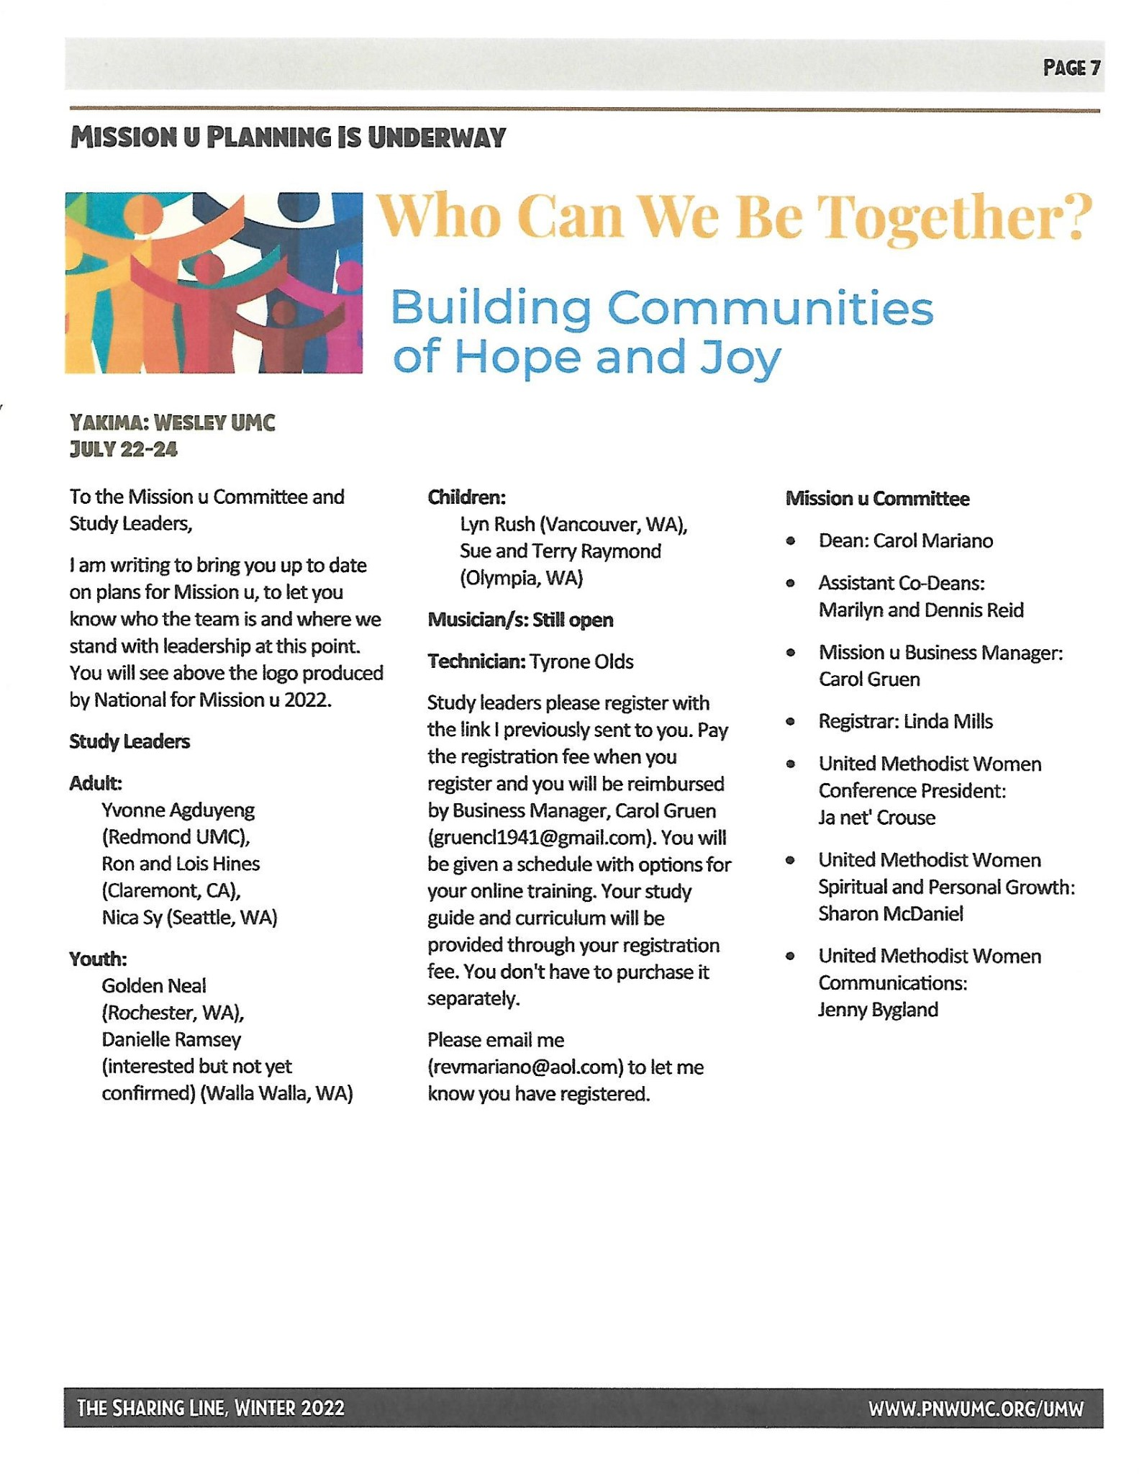
Inland Missional District
United Methodist Women
3928 N. Howard
Spokane WA 99205

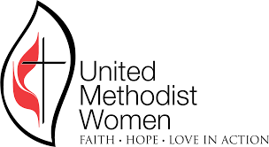
SAVE THE DATE!
Inland Missional District
United Methodist Women
2022 Annual Meeting

The Meeting will be on September 17, 2022
At Spokane Valley United Methodist Church
Spokane Valley WA

As plans are made, updates will be sent out
Patsy Charlton, Vice President

